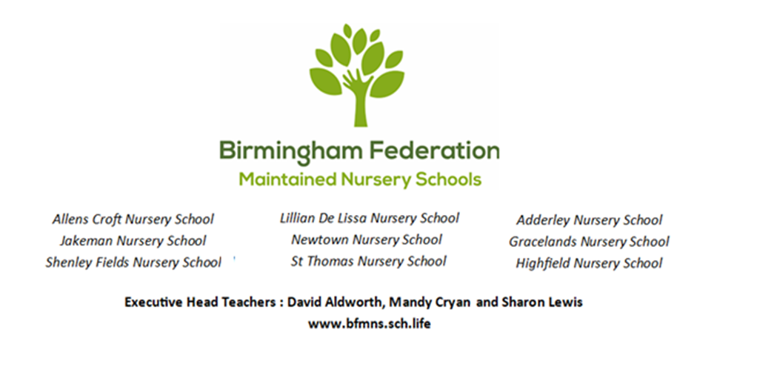

|  |  |  |
| --- | --- | --- |
| *Adderley Nursery School* | *Allens Croft Nursery School* | *Gracelands Nursery School* |
| *Highfield Nursery School* | *Jakeman Nursery School* | *Lillian de Lissa Nursery School* |
| *Newtown Nursery School* | *Shenley Fields Nursery School* | *St Thomas Centre Nursery School* |

**ADMISSIONS POLICY**

Full Governing Body Approved: 07 April 2025

Date for renewal: Spring 2027

Chair of Governors: Sean Delaney

Contents

Statement of Intent 2

Free Early Education Entitlement (EEE) Places 2

Free Childcare/Early Education for Working Parents of Children from Nine Months Old 2

Free Childcare/ Early Education Entitlement for Two-Year-Olds 4

Free Childcare/Early Education Entitlement for ALL Three- and Four-Year-Olds – ‘Universal offer’ 5

Fee-paying places 5

Admissions criteria 5

Criteria for the allocation of the Free Early Years Entitlement in LA nursery schools 5

Children not resident in the area of Birmingham City Council 6

This policy is in accordance with the 1989 United Nations Convention on the Rights of the Child (UNCRC).

***Article 2*** *(non-discrimination) The Convention applies to every child without discrimination, whatever their ethnicity, sex, religion, language, abilities or any other status, whatever they think or say, whatever their family background.*

***Article 3*** *(best interests of the child) The best interests of the child must be a top priority in all decisions and actions that affect children.*

***Article 28*** *(right to education) Every child has the right to an education. Primary education must be free and different forms of secondary education must be available to every child. Discipline in schools must respect children’s dignity and their rights. Richer countries must help poorer countries achieve this.*

***Article 31*** *(leisure, play and culture) Every child has the right to relax, play and take part in a wide range of cultural and artistic activities.*

### Statement of Intent

It is our intention to make our nursery schools accessible to children and families from all sections of the local community. We aim to ensure that children have access to the nursery school through open, fair and clearly communicated procedures, ensuring that every child is included and supported.

## Free Early Education Entitlement (EEE) Places

**(*free to parents, funded by the government)**

### Free Childcare/Early Education for Working Parents of Children from Nine Months Old

Currently available for children 9 months – 4 years (April 2025):

Children aged 9 months – 3 years: Up to 15 hours of early education over 38 weeks of the year.

Children aged 3-4 years: Up to 30 hours of early education over 38 weeks of the year.

Can be used flexibly with one or more childcare providers.

Available for children 9 months – 4 years (September 2025):

Children aged 9 months – 4 years: Up to 30 hours of early education over 38 weeks of the year.

Can be used flexibly with one or more childcare providers.

Click on the link below for further information regarding childcare funding:

<https://www.childcarechoices.gov.uk/>

*The 30 hours free childcare is only for 38 weeks of the year, not 48 weeks. This is equivalent to school term times.*

#### How will parents know what to do?

Parents can check whether they could be eligible for a range of government childcare offers, including 30 hours, via Childcare Choices at: <https://www.childcarechoices.gov.uk> or the Childcare Calculator at: <https://www.gov.uk/childcare-calculator>.

#### Eligibility

The eligibility for the working parent funded free childcare is:

* Both parents must be working – or if a single parent, then they must be working
* Each parent earns, on average, a weekly minimum equivalent to 16 hours at National Minimum Wage or National Living Wage
* A joint parent family with one parent working (a minimum equivalent to 16 hours at National Minimum Wage or National Living Wage), and one parent unable to work as they are an official carer or in receipt of disability benefit
* A lone parent who is working a minimum equivalent to 16 hours at National Minimum Wage or National Living Wage
* Parents must have an annual income of less than £100.000
* Must live in England
* Parents are also eligible if they are self-employed or on a zero-hour contract, as long as they earn at least the equivalent of 16 hours at the National Minimum Wage.

#### How will parents apply for 30 hours?

As part of the application process, parents will be asked to enter personal details including their name, address and National Insurance number and the same details for their partner (if they have one). They will also be asked whether they expect to meet the income requirements over the coming three months and whether they are in receipt of any relevant benefits. This information will help HMRC decide whether the parent (and their child) are eligible for 30 hours. At the start of the application process, parents will create a Government Gateway account if they don’t already have one.

**If parents encounter any problems with the application process or accessing the childcare account, they should direct their queries to the childcare service Customer Interaction Centre on 0300 123 4097.**

At the end of the application process, parents will have a childcare service account. In the “secure messages” section of their account, parents will receive messages regarding their eligibility. If parents are eligible, they will be given an 11 digit ‘eligibility code’ for their child. They will be asked to take this code (along with their National Insurance number and child’s date of birth) to their provider to claim their place. These codes normally start with ‘5000’. However, there are a small number of cases where parents might have a temporary code starting with ‘11’.

Parents will be prompted every three months to reconfirm the details they entered on their application are still accurate. This is to check that they are still eligible. They will be prompted, via text message and/or email, four weeks before their reconfirmation deadline and again two weeks before the deadline if they still haven’t reconfirmed. If their circumstances have changed, they will log into their childcare service account, amend their details and then resubmit their details. If their circumstances have not changed, they only need to reconfirm their details.

If parents miss the reconfirmation deadline, they will receive a message telling them that their eligibility has lapsed. Although they are no longer eligible, they may be able to retain their childcare place for a short period; this is known as a grace period.

**Parents should be reminded that childcare providers will require:**

* their eligibility code
* National Insurance number
* child’s date of birth

This information is required to enable providers to verify the code and offer the EEE place.

### Free Childcare/ Early Education Entitlement for Two-Year-Olds

#### Eligibility

15 hours of early education for 2-year-olds is available to children whose families meet one of the following thresholds:

* Universal credit
* Income support
* Income-based Job Seekers' Allowance
* Income-related Employment and Support Allowance (If you are unable to work due to

illness or a disability)

* Support under Part VI of the Immigration and Asylum Act 1999
* The Guarantee element of the State Pension Credit; or Child Tax Credit, provided they have an annual gross income of no more than £16,190 as assessed by Her Majesty’s Revenue and Customs (HMRC).
* Working Tax Credits (including those in receipt during the four-week period immediately

after their employment ceases, or after they start to work fewer than 16 hours per week)

with a household income of less than £16,190 as assessed by HMRC.

* The child has a current statement of special educational needs or an Education, health

and Care plan.

* The child is in receipt of the Disability Living Allowance.
* The child is looked after by their local authority (LAC)
* The child has left care through special guardianship or an adoption or residence order

#### No Recourse to Public Funds (NRPF)

The eligibility for 2-year-olds has been extended to include all families that have ‘No

recourse to public funds (NRPF).

This guide has been developed to enable childcare providers to determine eligibility for 2-year-old EEE funded places for families who are non-UK citizens and have no recourse to public funds.

The rationale for extending eligibility is that the most disadvantaged 2-year-olds should be able to access early education regardless of their circumstances. While some NRPF families have been eligible for some time, the Department for Education (DFE) recognised there are more disadvantaged children whose parents have NRPF that were unable to access the 2-year-old entitlement.

What groups fall under NRPF?

These groups include, but may not be limited to children of:

* Zambrano carers
* families who have no recourse to public funds with a right to remain in the UK on grounds of private and family life under Article 8 of the European Convention on Human Rights
* families receiving support under Section 17 of the Children Act 1989 who are also subject to a no recourse to public funds restriction
* those who have claimed asylum in the UK and are waiting for a decision (known as ‘part 6’)
* a subset of failed asylum seekers supported under Section 4 of the Immigration and Asylum Act 1999
* Chen carers
* families holding a BN(O) passport
* spousal visa holders
* work visa holders
* student visa holders
* those with no immigration status
* those with a UK Ancestry Visa
* those with temporary protection status under Section 12 of the Immigration and Nationality Act
* those with pre-settled status who do not meet the qualifying right to reside tes

### Free Childcare/Early Education Entitlement for ALL Three- and Four-Year-Olds – ‘Universal offer’

#### Eligibility

* 15 hours of early education for all 3-year-olds from the term after their third birthday (universal offer)
* **Parents will not need to apply through the digital childcare service if they only want to claim the universal 15 hours entitlement for three- and four-year-olds.**

### Fee-paying places

* Fee paying places can be used to ‘top up’ a part-time 15-hour place to create a full-time place, OR as a part-time 2 year old place if you do not meet either eligibility criteria (above).

If parents encounter any problems with the application process or accessing the childcare account, they should direct their queries to the childcare service Customer Interaction Centre on 0300 123 4097.

## Admissions criteria

Our schools follow the Birmingham City Council Admissions Criteria. We admit new children all year round, in particular at the start of each term when children’s eligibility starts.

### Criteria for the allocation of the Free Early Years Entitlement in LA nursery schools

Where a maintained nursery school has more applications for free entitlement places than there are places available, the following criteria shall apply:

1. Looked After Children (LAC) and previously Looked After Children (PLAC)
2. Children with an older brother or sister already at the nursery school at the point of applying, who will still be in attendance at the time the sibling enters the nursery school. Siblings are considered to be those children who live at the same address and either:

* have one or both natural parents in common;
* are related by a parent’s marriage;
* are adopted or fostered by a common parent.

1. Distance from the school

Within each of these categories, priority is given to those who live nearest to the school, by

straight-line measurement to one fixed point in the school.

Home addresses

A pupil’s home address is considered to be a residential property that is the child’s only or main

residence and is either:

1. Owned by the child’s parent(s), or the person with parental responsibility for the child;

2. Leased to or rented by the child’s parent(s), or the person with parental responsibility.

Evidence of ownership or rental agreement may be required, plus proof of permanent residence at

the property concerned.

Where parents have shared responsibility for a child, and the child lives with both parents for part

of the week then the main residence will be determined as the address where the child lives the

majority of the week. Parents may be requested to supply documentary evidence to support the

address used for the allocation.

If a school is allocated on the basis of an address that is subsequently found to be different from a

child’s normal and permanent home address, then that place is liable to be withdrawn.

If you have any concerns based on decisions made using the oversubscription criteria, please refer to our complaints policy.

1. The order in which the application is received for funded places. Places will be offered on a first come, first served basis for applications that fall outside of the first two criterion, regardless of the type of funded place (e.g. universal three- and four-year-old place, working parent funded place, 2-year-old entitlement place).
2. Fee-paying places

### Children not resident in the area of Birmingham City Council

Children not resident in the area of Birmingham City Council may be admitted to a Birmingham LA

nursery school or class in line with the criteria above.